Vue 编程

# Vue环境搭建

Vue环境搭建包含node.js和npm两个部分。

## 准备node.js环境

### 安装node.js

打开 <https://nodejs.org/zh-cn/> 网址下载 node.js，如下图所示：

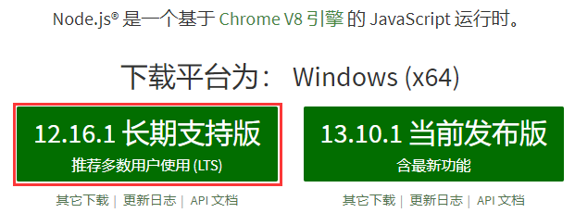

下载下来之后，进行安装，我这里是安装到 C:\NodeJS 目录下，如下图所示：

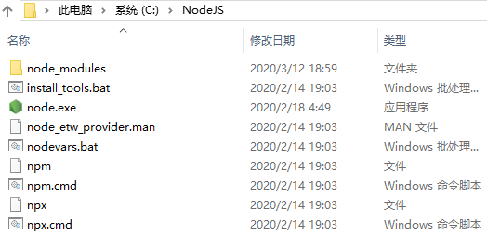

### 配置 node.js

然后把 node.js 的路径配置到 Path 环境变量，如下图所示：

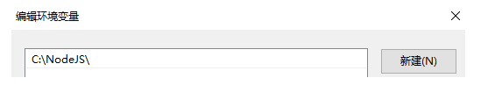

### 检查安装结果

在命令行输入：

|  |
| --- |
| node -v |

如下图所示：

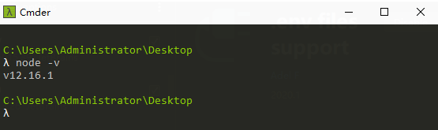

说明node.js的安装和配置没有问题。

## 安装 npm 包管理器

### 安装 npm 的阿里镜像

在命令行输入如下命令：

|  |
| --- |
| npm i -g cnpm --registry=https://registry.npm.taobao.org |

结果如下所示：

|  |
| --- |
| C:\Users\Administrator\Desktop  λ npm i -g cnpm --registry=https://registry.npm.taobao.org  C:\Users\Administrator\AppData\Roaming\npm\cnpm -> C:\Users\Administrator\AppData\Roaming\npm\node_modules\cnpm\bin\cnpm  + cnpm@6.1.1  added 686 packages from 950 contributors in 49.339s |

### 安装 Vue 的脚手架工具 vue-cli

在命令行输入如下命令：

|  |
| --- |
| npm i -g vue-cli |

安装过程如下：

|  |
| --- |
| C:\Users\Administrator\Desktop  λ npm i -g vue-cli  npm WARN deprecated vue-cli@2.9.6: This package has been deprecated in favour of @vue/cli  npm WARN deprecated request@2.88.2: request has been deprecated, see https://github.com/request/request/issues/3142  npm WARN deprecated coffee-script@1.12.7: CoffeeScript on NPM has moved to "coffeescript" (no hyphen)  C:\Users\Administrator\AppData\Roaming\npm\vue -> C:\Users\Administrator\AppData\Roaming\npm\node_modules\vue-cli\bin\vue  C:\Users\Administrator\AppData\Roaming\npm\vue-init -> C:\Users\Administrator\AppData\Roaming\npm\node_modules\vue-cli\bin\vue-init  C:\Users\Administrator\AppData\Roaming\npm\vue-list -> C:\Users\Administrator\AppData\Roaming\npm\node_modules\vue-cli\bin\vue-list  + vue-cli@2.9.6  added 240 packages from 205 contributors in 178.526s |

检验是否安装成功：

|  |
| --- |
| vue -V |

过程如下：

|  |
| --- |
| C:\Users\Administrator\Desktop  λ vue -V  2.9.6 |

## 安装 webpack 工具

在命令行输入如下代码：

|  |
| --- |
| cnpm install -g webpack |

安装过程如下：

|  |
| --- |
| C:\Users\Administrator\Desktop  λ cnpm install -g webpack  Downloading webpack to C:\Users\Administrator\AppData\Roaming\npm\node_modules\webpack_tmp  Copying C:\Users\Administrator\AppData\Roaming\npm\node_modules\webpack_tmp\_webpack@4.42.0@webpack to C:\Users\Administrator\AppData\Roaming\npm\node_modules\webpack  Installing webpack's dependencies to C:\Users\Administrator\AppData\Roaming\npm\node_modules\webpack/node_modules  [1/23] acorn@^6.2.1 installed at node_modules\_acorn@6.4.1@acorn  [2/23] eslint-scope@^4.0.3 installed at node_modules\_eslint-scope@4.0.3@eslint-scope  [3/23] json-parse-better-errors@^1.0.2 installed at node_modules\_json-parse-better-errors@1.0.2@json-parse-better-errors  [4/23] chrome-trace-event@^1.0.2 installed at node_modules\_chrome-trace-event@1.0.2@chrome-trace-event  [5/23] @webassemblyjs/helper-module-context@1.8.5 installed at node_modules\_@webassemblyjs_helper-module-context@1.8.5@@webassemblyjs\helper-module-context  [6/23] loader-runner@^2.4.0 installed at node_modules\_loader-runner@2.4.0@loader-runner  [7/23] @webassemblyjs/wasm-parser@1.8.5 installed at node_modules\_@webassemblyjs_wasm-parser@1.8.5@@webassemblyjs\wasm-parser  [8/23] ajv-keywords@^3.4.1 installed at node_modules\_ajv-keywords@3.4.1@ajv-keywords  [9/23] @webassemblyjs/ast@1.8.5 installed at node_modules\_@webassemblyjs_ast@1.8.5@@webassemblyjs\ast  [10/23] memory-fs@^0.4.1 installed at node_modules\_memory-fs@0.4.1@memory-fs  [11/23] enhanced-resolve@^4.1.0 installed at node_modules\_enhanced-resolve@4.1.1@enhanced-resolve  [12/23] tapable@^1.1.3 existed at node_modules\_tapable@1.1.3@tapable  [13/23] @webassemblyjs/wasm-edit@1.8.5 installed at node_modules\_@webassemblyjs_wasm-edit@1.8.5@@webassemblyjs\wasm-edit  [14/23] mkdirp@^0.5.1 installed at node_modules\_mkdirp@0.5.1@mkdirp  [15/23] ajv@^6.10.2 installed at node_modules\_ajv@6.12.0@ajv  [16/23] schema-utils@^1.0.0 installed at node_modules\_schema-utils@1.0.0@schema-utils  [17/23] neo-async@^2.6.1 installed at node_modules\_neo-async@2.6.1@neo-async  [18/23] loader-utils@^1.2.3 installed at node_modules\_loader-utils@1.4.0@loader-utils  [19/23] webpack-sources@^1.4.1 installed at node_modules\_webpack-sources@1.4.3@webpack-sources  [20/23] node-libs-browser@^2.2.1 installed at node_modules\_node-libs-browser@2.2.1@node-libs-browser  [21/23] micromatch@^3.1.10 installed at node_modules\_micromatch@3.1.10@micromatch  platform unsupported watchpack@1.6.0 › chokidar@2.1.8 › fsevents@^1.2.7 Package require os(darwin) not compatible with your platform(win32)  [fsevents@^1.2.7] optional install error: Package require os(darwin) not compatible with your platform(win32)  [22/23] watchpack@^1.6.0 installed at node_modules\_watchpack@1.6.0@watchpack  [23/23] terser-webpack-plugin@^1.4.3 installed at node_modules\_terser-webpack-plugin@1.4.3@terser-webpack-plugin  Recently updated (since 2020-03-05): 2 packages (detail see file C:\Users\Administrator\AppData\Roaming\npm\node_modules\webpack\node_modules\.recently_updates.txt)  Today:  → loader-utils@1.4.0 › json5@1.0.1 › minimist@^1.2.0(1.2.4) (03:25:14)  2020-03-09  → acorn@^6.2.1(6.4.1) (18:39:06)  All packages installed (295 packages installed from npm registry, used 10s(network 9s), speed 511.61kB/s, json 269(509.35kB), tarball 4.2MB)  [webpack@4.42.0] link C:\Users\Administrator\AppData\Roaming\npm\webpack@ -> C:\Users\Administrator\AppData\Roaming\npm\node_modules\webpack\bin\webpack.js  C:\Users\Administrator\Desktop  λ |

# Vue项目示例

## 项目创建

在我们的工作空间输入如下代码：

|  |
| --- |
| vue init webpack vue_study |
| 格式为:  vue init webpack 项目名 |

然后进入配置过程：

|  |
| --- |
| ? Target directory exists. Continue? Yes  ? Project name vue_study  ? Project description A Vue.js project  ? Author OrangeZheng # 填写作者名称，其他一路默认  ? Vue build standalone  ? Install vue-router? Yes  ? Use ESLint to lint your code? Yes  ? Pick an ESLint preset Standard  ? Set up unit tests Yes  ? Pick a test runner jest  ? Setup e2e tests with Nightwatch? Yes  ? Should we run `npm install` for you after the project has been created? (recommended) npm |

然后就是比较长时间的安装过程，安装最后显示如下信息：

|  |
| --- |
| Running eslint --fix to comply with chosen preset rules...  # ========================  > vue_study@1.0.0 lint D:\WorkSpace\vue\vue_study  > eslint --ext .js,.vue src test/unit test/e2e/specs "--fix"  # Project initialization finished!  # ========================  To get started:  cd vue_study  npm run dev  Documentation can be found at https://vuejs-templates.github.io/webpack |

最后安装结果如下图所示：

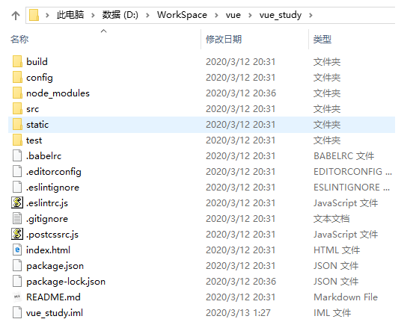

## 项目运行

|  |
| --- |
| D:\WorkSpace\vue  λ cd vue_study  D:\WorkSpace\vue\vue_study  λ npm run dev |

运行时，需要打包的过程，完整过程如下：

|  |
| --- |
| D:\WorkSpace\vue  λ cd vue_study  D:\WorkSpace\vue\vue_study  λ npm run dev  > vue_study@1.0.0 dev D:\WorkSpace\vue\vue_study  > webpack-dev-server --inline --progress --config build/webpack.dev.conf.js  13% building modules 25/33 modules 8 active ...e_study\src\components\HelloWorld.vue{ parser: "babylon" } is deprecated; we now treat it as { parser: "babel" }.  95% emitting  DONE Compiled successfully in 46711ms 9:59:57  I Your application is running here: http://localhost:8080 |

然后我们在浏览器输入：<http://localhost:8080/> 如下图所示：

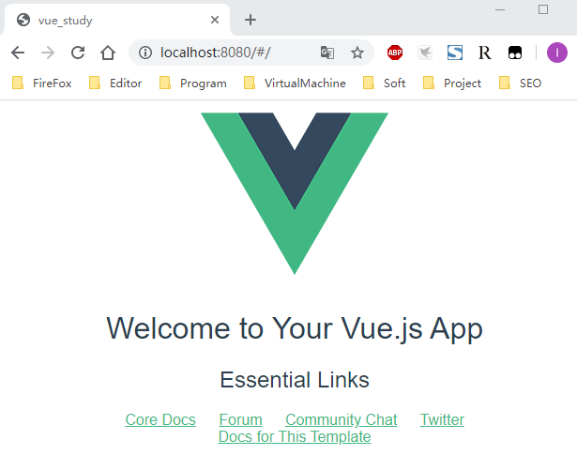

说明我们的 Vue 项目创建成功了。

## 项目编码

在 IntelliJ IDEA 以 Import Module 的方式导入 Vue 项目，如下图所示：

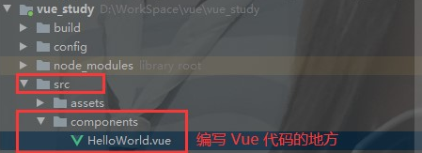

参考地址：

<https://blog.csdn.net/CCIEJohn_zhou/article/details/89043500>